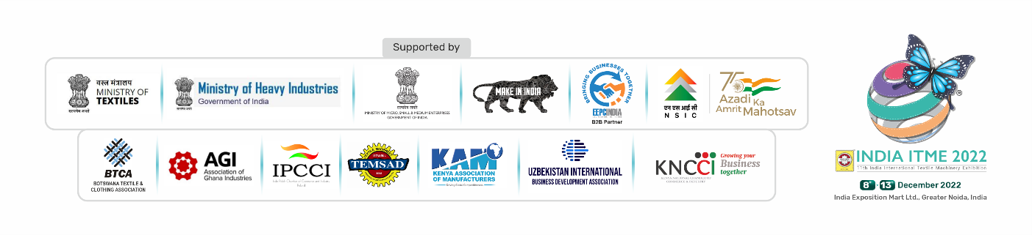
07th October 2022

Sub: Invitation to mount a delegation at India ITME 2022

Dear Sir / Madam,

Greetings & good wishes from India ITME Society!

It is our pleasure to invite your Association to mount a business delegation of members from the Textile Industry to India ITME 2022. This event undoubtedly would be an excellent platform for textile industry business visitors to meet & network for new business opportunities both with Indian textile industry as well as other countries.

11th India International Textile Machinery Exhibition (India ITME 2022) will be held from 8th to 13th December 2022 at IEML, Greater Noida, India. (https://itme2022.india-itme.com/) This Mega once in 4 years event is supported by Ministry of Textiles - Govt of India, Department of Heavy Industries - Govt of India, Ministry of Micro, Small & Medium Enterprises - Govt of India, Make in India - Department for Promotion of Industry and Internal Trade - Govt of India EEPC as B2B Partner & National Small Industries Corporation.

India being home to the world’s second largest textile industry, India is also a very important sourcing hub for textile machinery, Technology, Components & Allied Services. 22 chapters as listed below from fibre to finished products providing complete sourcing solutions, competitive pricing and latest technology are covered in this B2B event.

- Spinning & Spare parts for Spinning
- Weaving
- Processing
- Digital Printing
- Garment
- Knitting & Hosiery
- Embroidery & Braiding
- Non-Woven & Technical Textiles
- Dyestuffs & Chemical Products
- Laboratory Testing and Measuring Equipments
- Integrated Textile Parks
- Fibers and Yarns
- Software and Design
- Recycling & Waste Management

As Such, a very rich collection of textile technology, price competitive high quality textile machinery in all sectors is on display at India ITME 2022. This is the only event in India which brings together 73 Countries & 97 domestic regions Pan India.

India ITME Society jointly with EEPC is organizing Reverser Buyer Seller Meet & B2B meetings concurrent to India ITME 2022.

This Event would be an excellent platform for textile industry business visitor to meet & network for new business opportunity both with Indian industry as well as other countries. Hence, we would like to invite a business delegation from your Association & request the help to mount a delegation as above.

It is my pleasure to invite your Association to mound a business delegation comprising of Officials, Associations & Media representatives from the Textile Industry to this strategic event. This event undoubtedly would be an excellent platform for textile industry business visitors to meet & network for new business opportunities both with Indian textile industry as well as other countries.

On receival of your interest to mound a Business delegation we shall work out on a detailed itinerary
for the visit

Scan QR Code
For Visitor registration

We hope to hear from your association and look forward to welcoming the delegation from your Association to INDIA ITME 2022.

Thank-you & regards,

Seema Srivastava
Executive Director
----------------------------------------------------------------------------------------------------------------------
India ITME Society
“Promoting Trade through technology,
with commitment, integrity &
transparency of conduct”
Scan QR Code
to View India ITME 2022 Website
Projects
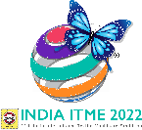
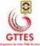
Follow/Like us on:
Skype: indiaitme2012
Website: https://itme2022.india-itme.com

